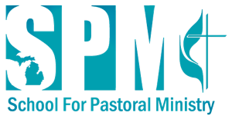
Michigan Conference of the United Methodist Church

SPREAD THE WORD
We hope you can join us for this year's
School for Pastoral Ministry presentation of
“Streams of Healing Water”

Featuring:
Rev. Junius B. Dotson, General Secretary/CEO Discipleship Ministries UMC
and
Rev. Kennetha Bigham-Tsai, Chief Connectional Officer of the Connectional Table UMC
Tuesday, August 20 – Wednesday, August 21
Rev. Junius B. Dotson
Nationally recognized speaker and author on evangelism and church revitalization. Launched "See All the People", the highly successful church-wide initiative that helps church leaders concentrate on intentional discipleship, while learning new behaviors around engaging their surrounding community.
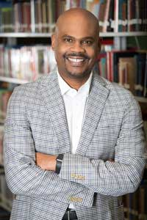
Rev. Kennetha Bigham-Tsai
"The mission is still alive," says Rev. Bigham-Tsai. Even in times of great anxiety, God will still be calling all United Methodists to mission in the world. We will still focus on the worldwide nature of our denomination and local church vitality. When asked if the church was "stuck" on one issue, she responded, "Being stuck is a choice."

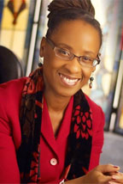
Register @ www.schoolforpastoralminitry.org
or Mail to: Rev. Jim Mort, PO Box C, 216 W Main St., Marion, MI. 9231) 743-2834
"Streams of
Healing Water"
SAVE THE DATE!
Michigan Conference
2019 School For Pastoral Ministry

AUGUST 20-21
Kellogg Center | East Lansing, MI
We hope you can join us for this year's
School for Pastoral Ministry presentation of
"Streams of Healing Water"
Featuring:
- Trapp Ministries Band from General
Conference
- Tuesday: Choice of 2 Workshops
- Tuesday Evening: Comedy Night with
Andy Benendigo
- Child Care will be available - see
registration form
- Discounts available for 1st time
attendees!
OUR MISSION
Through innovative ideas, proven practices, and fantastic fellowship, Michigan United Methodist clergy have a unique opportunity to renew their ability to proclaim God’s Good News in Christ with their lives and ministries. This conference is for all those who desire to reconnect with God and clergy colleagues, as they learn how to increase their relevance with the people in their ministry settings. We welcome clergy from
all denominations, conferences, and regions of the world!

